<https://emdcollection.github.io/>

Do not copy all of the information! Just copy/summarize parts!

Non – Linear:

Definitions:

* Asymptotes – A line the graph doesn’t cross, can be on the x or the y axis.
* Axis of Symmetry – Where the graph reflects itself.

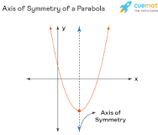

* Discriminant - $∆=b^{2}-4ac$, if $∆=0 there is 1 solution, ∆<0 there is no solution, ∆>0=2 solutions.$ If the number is a square number, there are 2 RATIONAL solutions, whereas if the number is not a square number there are 2 IRRATIONAL solutions.
* Translation – Shifting the graph horizontally and/or vertically.
* Reflection – Flipping the graph on its axis.
* Dilation – Wider or narrower compared to the original.

Different types of graphs:

* Exponential:

“K” will affect the graphs translation on the x-axis, a positive K will translate the graph to the left in however many units it is, whilst a negative K will translate the graph to the right in however many units it is.

“A” will affect the dilation and reflection on the graph. The higher the number “A” is, the narrower the graph will become, whilst the lower the number “A” is, the wider it will get. If “A” is 1, the graph will just be a straight horizontal line. If “A” is less than 1, then the graph will be reflected along the y-axis.

“H” will affect the graphs translation on the y-axis. A positive “H” will translate the graph upwards by however many unit’s “H” is, and a negative “H” will translate the graph downwards by however many units “H” is.

* Hyperbola:

“A” affects the dilation of the graph. A smaller value “A” will result in the hyperbola being closer to the point of origin, specifically the turning point of the hyperbola, whilst a larger value “A” will result in the hyperbola being further away from the point of origin.

“K” affects the vertical translation of the graph. A positive “K” will translate the graph upwards by however many units, whilst a negative “K” will translate the graph downwards by however may units.

“H” affects the horizontal translation of the graph. A positive “H” will translate the graph to the left by however many units, whilst a negative “H” will translate the graph to the right by however many units.

* Parabola:

“A” affects the dilation of the graph. If “A” is less than 1, the graph will be dilated wider than the standard $x^{2},$ thus the smaller “A” is, the wider the graph will be, whilst the larger “A” is, the narrower the graph will be. If “A” is negative the graph will be flipped, and the parabola will have a maximum turning point.

“H” affects the horizontal translation of the graph. A positive “H” will translate the graph left by however many units whilst a negative “H” will translate the graph right by however many units.

“K” affects the vertical translation of the graph. A positive “K” will translate the graph upwards by however many units, and a negative “K” will translate the graph downwards by however many units.

When y= ${ax}^{2}+bx+c$ the turning point of the quadratic equation parabola will be… $(-\frac{b}{2a} , c-\frac{b^{2}}{4a})$

If a>0 = minimum turning point.

If a<0 = maximum turning point.

* Circles :

The centre of the circle is (h,k), so if the equation is ${(x-5)}^{2}+{(y+7)}^{2}=16$

The centre of the circle would be (5, -7) since both flips.

The radius is simply just the square root of the answer (in this case 16), which would be 4, thus the radius of the circle would be 4, with eth centre being (5, -7)

* Ellipses: $\frac{{(x-h)}^{2}}{a}+\frac{{(y-k)}^{2}}{b}$

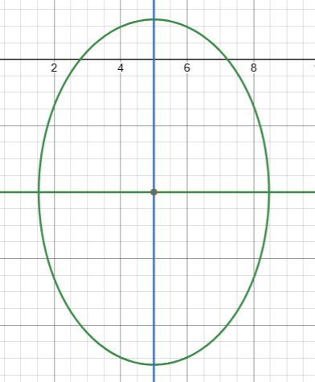

Like a circle, the centre of an ellipse is simply just (h,k).

The square root of “A” determines the distance from the centre along the x-axis.

The square root of “B” determines the distance from the centre along the y-axis.

**Inverse Proportions**

When given an exponential where x and y are inversely proportional (x increases as y decreases and visa versa), the rule is x $∝$ $\frac{k}{y}$, where k is the constant of proportionality. To find the constant of proportionality, use k = xy. $∝$ means proportional to.

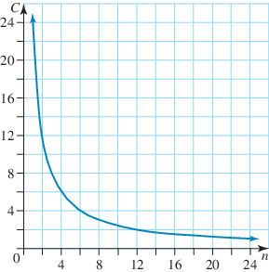As an example, 24 sweets between 4 kids is 6 sweets per kid. Between 3 kids, it would be 8 sweets per kid. The number of candy per kid and the number of kids are inversely proportional.

$$C∝\frac{k}{n}$$

To find k, lets take two C and n spots (3 and 4 for C, 8 and 6 for K) and multiply them with each other. 3 x 8 = 24, and 4 x 6 = 24. Therefore, the constant of proportionality is 24.

Probability:

Definitions:

* Ind66sependent and Dependant Events: independent events are events that aren’t affected by any other event. Dependant events are affected by other events.
  + A and B are independent of each other if $\operatorname{Pr}\left(A∩B\right)=\operatorname{Pr}\left(A\right)×\operatorname{Pr}\left(B\right)$
* Sample Space: the set of all possible outcomes (represented by $ξ$)
* Experimental probability: the chance of an event happening based on the outcome of an experiment.
  + Experimental probability = successful trial / all trials
* Theoretical probability: the chance of an event happening based on given probabilities that haven’t been experimented.
  + Theoretical probability = favourable outcomes / all outcomes
    - Simplified to $\operatorname{Pr}\left(e\right)=\frac{N(e)}{N(ξ)}$ (e represents favourable outcomes)
* Pr(n): the probability of an event happening, usually represented as a fraction or percentage.
* N(n): the number of outcomes that suffice the conditions.
  + N($ξ$) is the number of outcomes.
* Intersection: outcomes that are part of both/all parts. For example, $A∩B$ would include elements that are in both A and B.
* Unison: outcomes that are in either one or the other or both/all parts. For example, $A∪B$ would include elements that are in A, B, and $A∩B$.
* Additional Law of Probability: the formula to find the unison between two parts. This is done by adding up both A and B (which would include where the two intersect twice) and subtracting the intersection of A and B, which removes the additional intersection calculated.
  + The formula is $\operatorname{Pr}\left(A∪B\right)=\operatorname{Pr}\left(A\right)+\operatorname{Pr}\left(B\right)-Pr⁡(A∩B)$
* Given: the probability of an event occurring given that an event has already occurred. For an example, consider the following table.

|  |  |  |  |
| --- | --- | --- | --- |
|  | **Male** | **Female** | **Total** |
| **Smoker** | 40 | 60 | 100 |
| **Non-Smoker** | 80 | 20 | 100 |
| **Total** | 120 | 80 | **200** |

* With this graph, we need to find the probability that a person who was surveyed is a smoker given that they were male. To find this, only consider the male total. There are 40 male smokers, and 80 male non-smokers, for a total of 120 males surveyed. To find Pr(smoker | male), get the amount of male smokers (40) and divide it by the total of males (120). We get Pr(smoker | male) = 40/120 = 1/3.
* Factorial: a number multiplied by 1 less than it, multiplied by 2 less than it, etc.
  + 4! = 4 x 3 x 2 x 1
  + 99! = 99 x 98 x 97 x 96 x 95…
  + 0! = 1
* Permutation: an arrangement of a list of items with an order, and the order matters.
  + It is written as nPr or (irregularly) P(n,r)
  + For an example, you need to award 3 out of 8 peopled medals in a race. Since the medals given dictate who is left and who won, the order matters.
    - This means the total options are 8 x 7 x 6 = 336
    - We use factorials to get to this, but since 8! = 8 x 7 x 6 x 5 x 4 x 3 x 2 x 1, we need to get rid of some numbers. We do this by dividing the factorial 8! by 5!, as we need to get rid of the numbers from 5 down.
    - This is written as $\frac{8!}{5!}$.
    - To convert this to P(n,r) or nPr, we need to find what factorial subtracted from 8 is equal to 5. In this case, it is 3.
      * This rule is can be written as $\frac{8!}{(8-3)!}$, aka $\frac{n!}{(n-k)!}$
      * The variables n and k are the equivalent to the number of items you have and the number of items you want to sort respectively. In this case, it can mean “use the first 3 items of 8.”
* Combinations: an arrangement of a list of items, where order doesn’t matter.
  + It is written as nCr or (irregularly) C(n,r)
  + For an example, say you have 3 cakes and want to distribute them to 8 friends. In this case order doesn’t matter, because giving cake to someone first isn’t different to giving it them last.
    - We have 3 choices for the first person, 2 for the second person, and 1 for the third person, so the factorial is 3 x 2 x 1 = 6.
    - To find the Combination, we must first find the Permutation. We know that P(n,r) = P(8,3) = 336
    - To find the Combination, we must follow the rule C(n,r) = $\frac{P\left(n,r\right)}{r!}$
      * This is also equal to C(n,r) = $\frac{n!}{\left(n-r\right)!r!}$
      * In this case, C(n,r) = $\frac{P\left(8,3\right)}{3!}$ Or $\frac{8!}{5!3!}=56$, thus there are 56 ways 3 cakes can be distributed to 8 people ignoring the order given that it doesn’t matter.
* For tree diagrams, you must include the name of the event at the end of the branch, and the chance of that happening next to the outcome. At the end of every ending branch, you need the full outcome labelled, and it might help to have the probability for that outcome to occur next to it.  
    
  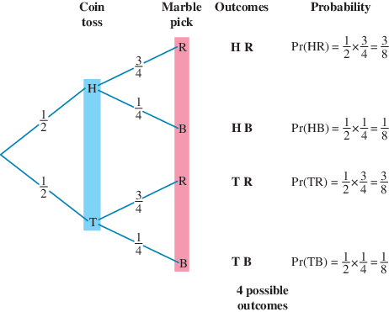
* For Venn Diagrams (if you have to draw one) make sure every outcome is labelled and every value is labelled, including values that don’t fit any of the conditions.

When multiple probabilities compound ((A | B) U C), you need to consider each individually, and calculate them. Consider the Venn diagram below.

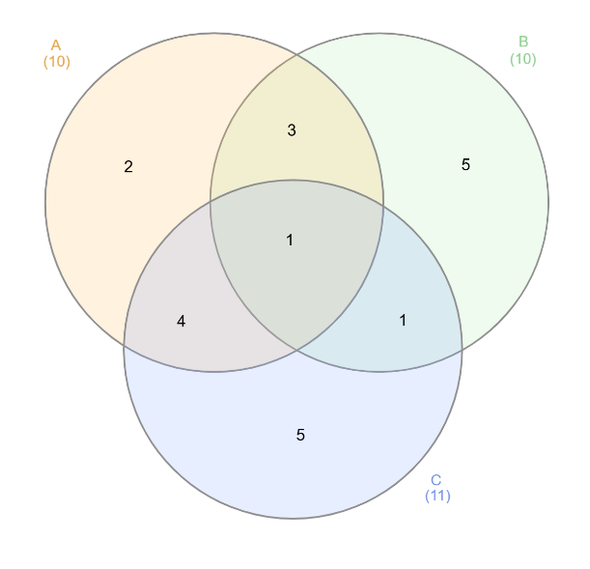Lets say the question is Pr(B | (A U C)). Lets consider the (A U C) part first.

$$\operatorname{Pr}\left(A∪C\right)=16/21$$

Now, lets consider the B | part. Given that only 16 of the elements fit as A U C, what’s the chance that an element is also part of B. We can calculate this using the formula for given.

$$\operatorname{Pr}\left(B|(A∪C)\right)=B∩(A∪C)/\operatorname{Pr}\left(A∪C\right)$$

If Pr(B | A) = Pr(A ∩ B)/Pr(A), and in this case A is actually A U C, then the substituted equation is the one above.

The result from this is $\operatorname{Pr}\left(B|(A∪C)\right)=\frac{\frac{5}{21}}{\frac{16}{21}}=\frac{5}{16}$

Polynomials:

Polynomial – An expression containing only positive powers of $x$.

Degree – The highest power of the VARIABLE X in the expression, eg:

🡪 The degree in this expression is 4.

The degree in the constant “10” would just be 0, as we can think of it as ${10x}^{0}$.

The leading term is the **TERM** containing the highest power, for example in the equation ${3x}^{2}+2x+4$ the leading term is ${3x}^{2}$.

The leading co-efficient is the **CO-EFFICIENT** of the leading term, for example, in the equation ${3x}^{2}+2x+4$ the leading co-efficient is 3.

The variable is simply just the variable being used in the equation, eg: x,y,z,a,b,c, etc.

Divisor – The expression and/or number on the left side of the long division equation (the number the dividend is being divided by).

Dividend – The expression and/or number on the right of the long division equation or also known as under the branch in the long division equation. It is also the number being divided.

Quotient is the answer to the long division equation.

The remainder is the number left over.

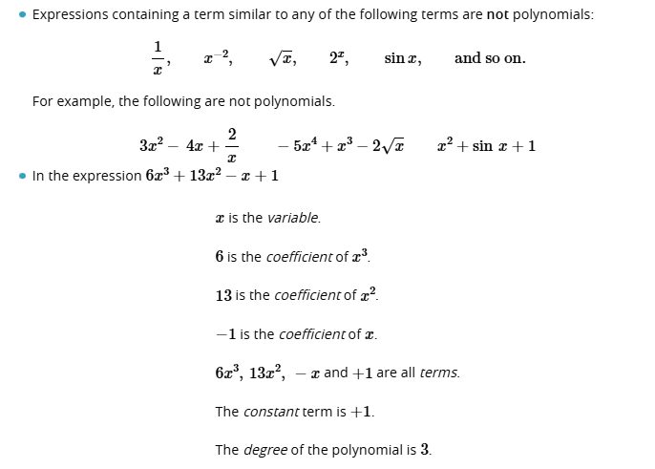

Adding, Subtracting, and Multiplying Polynomials:

When adding and subtracting polynomials, group the like terms and then simply add or subtract the with each other until it can no longer be further simplified.

When multiplying polynomials, simply use the FOIL method and then simplify.

Dividing Polynomials:

Steps:

1. Write the equation in long division form.
2. Identify your leading term (in this case the leading term is 2x)
3. Now determine how many of your leading term go into ${2x}^{4}$ or more simply, 2x times what equals ${2x}^{4}$? The answer to that would be $x^{3}$.
4. Write your answer on the top of the long division.
5. Now multiply the divisor (the expression on the left-hand side of the equation) by the first part of the answer we have (in this case $x^{3}$) so it will be $(2x+3)×x^{3}$.
6. Write the answer to that expression (the answer is ${2x}^{4}+{3x}^{3}$) and write it below the dividend, as seen in the example below where ${2x}^{4}+{3x}^{3}$ is written below ${2x}^{4}+{5x}^{3}$.
7. Subtract those two expressions so it will be $\left({2x}^{4}+{5x}^{3}\right)-({2x}^{4}+{3x}^{3})$ which will equal ${2x}^{3}.$ Write that below the subtracting equation, as shown in the example below.
8. Bring down the next term.
9. Repeat steps 3 to 8 by starting by dividing the leading term with the term that was the answer to the subtraction step.

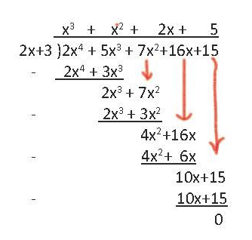

Piecewise:

Piecewise is multiple equations which make up one line. An example is below, which include a straight line, a parabola, a linear relation, and a trigonometric relation.

To make a piecewise graph equation, you must follow some rules. A piecewise equation is written like this:

$$f\left(x\right)=\left\{\begin{aligned}{\left(x+2\right)}^{2}-4, &0<x<2 \\ \frac{12}{x} , &2≤x\end{aligned}\right.$$

As you can see, the equation of the line is listed first, followed by the domain of the equation. This means a certain equation for a line is limited to a specific domain, which allows you to string together multiple relations.

A domain is simply two x values which dictate where an equation is true. Using the equation above, 12/x is only true when x is between 0 and 2, excluding 0 and 2. This means 12/0, 12/2, 12/-1, 12/3 and so on are not drawn because they don’t fall in the domain.

If a part of a piecewise equation is in a domain where the line is only less than or greater than a number but not equal to it (for example, 2 < x < 4, where x technically doesn’t equal 2 or 4, but everything in between), then the dot marking the end of the line should be hollow, or only an outline. If it is part of the domain (for example, 2 <= x <= 4, where x is equal to 2 and 4), then the dot marking the end of the line should be opaque or filled out.

$$f\left(x\right)=\left\{\begin{aligned}{\left(x+2\right)}^{2}-4, &0<x<2 \\ \frac{12}{x} , &2≤x\end{aligned}\right.$$

In terms of form, f(x) can be interchanged with y, and the commas after the separate line equations can instead be “if” to indicate that an equation is true if it’s in a certain domain.

Separate lines also do not need to connect to each other. They can abruptly change y values.